Experiment 1

Setting Up Python Environment and Libraries – Jupyter Notebook

Aim: To configure Python, Jupyter Notebook and verify the installation of essential data analytics libraries using the Space Mission dataset.

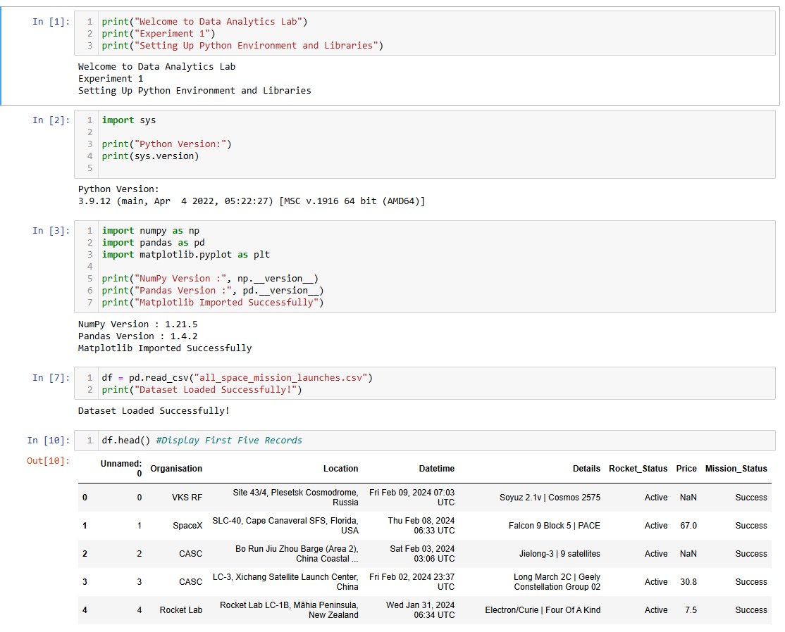
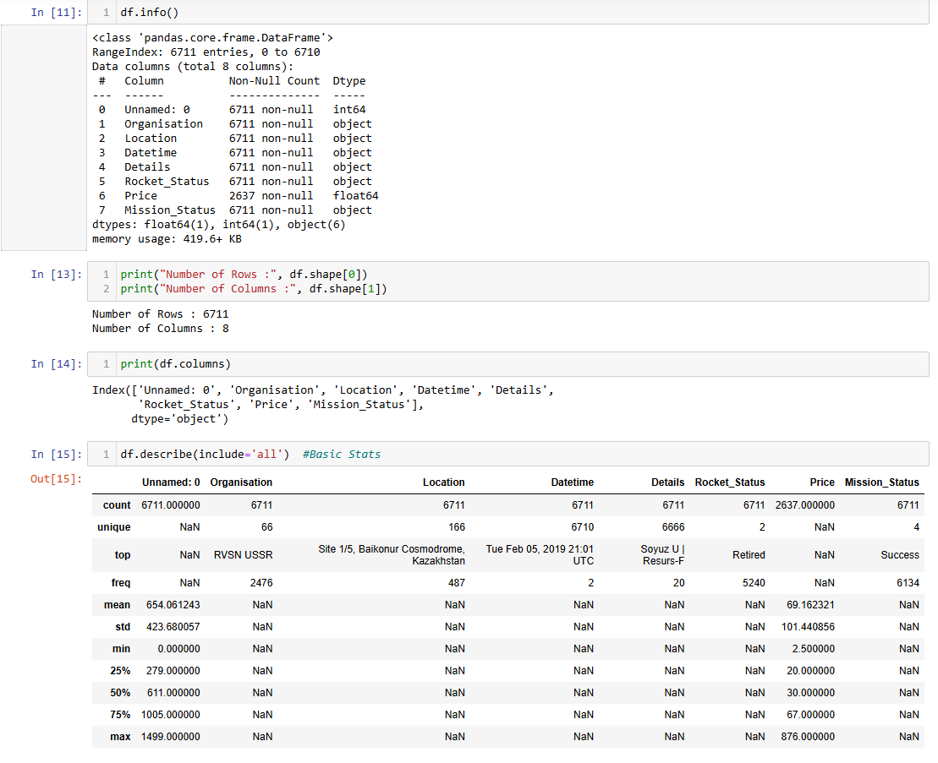
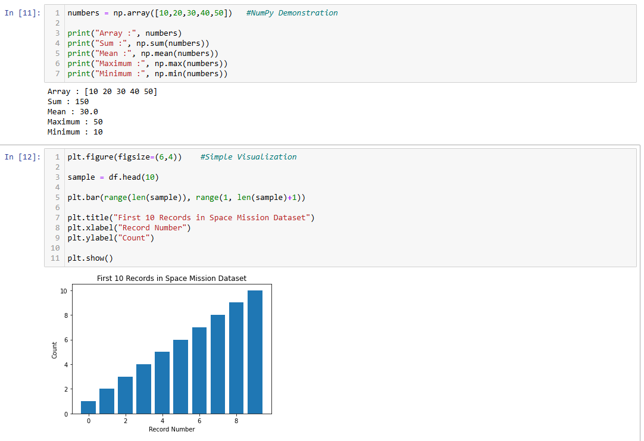

Experiment 2: Exploratory Data Analysis (EDA) – Data Import and Export
Aim:
To import the Space Mission dataset from various sources, perform basic exploratory data analysis using Pandas, and export the processed data into different file formats.
Dataset: all_space_mission_launches.csv

